Adaptive Prediction filters using LabVIEW

# What is LabVIEW?

LabVIEW is a graphical programming environment used by millions of engineers and scientists to develop sophisticated measurement, test, and control systems using intuitive graphical icons and wires that resemble a flowchart. It offers unrivaled integration with thousands of hardware devices and provides hundreds of built-in libraries for advanced analysis and data visualization – all for creating virtual instrumentation. The LabVIEW platform is scalable across multiple targets and OSs, and, since its introduction in 1986, it has become an industry leader.

## Top Features

* [**Faster Programming**](http://sine.ni.com/#fasterprogramming)**.**
* **Hardware Integration with LabVIEW**: It can connect to any instrument or sensor with built-in libraries and thousands of instrument drivers.
* **Advanced Built-In Analysis and Signal Processing:** It has the ability toaccess thousands of engineering-specific functions such as frequency analysis, curve fitting, and more. It also Interact with measurements and perform inline analysis in real time on acquired signals.
* **Data Display and User Interfaces:** It has the ability tointeract with data using hundreds of drag-and-drop controls, graphs, and 3D visualization tools.
* **Multiple Programming Approaches:** Integrate text-based code and DLLs or easily incorporate native and third-party .m files.
* **Multicore Programming:** It has the ability tohandle large data sets and complex algorithms faster because LabVIEW inherently runs on multiple threads. It also can easily optimize code for parallel execution using built-in debugging and visualization tools.[1]

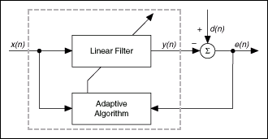We can implement an LMS adaptive filter using the LabVIEW Adaptive Filter Toolkit. We also can implement an LMS adaptive filter using the LabVIEW graphical development environment without the Adaptive Filter Toolkit.

Adaptive filter

Example: Implementation of LMS adaptive filter [2]

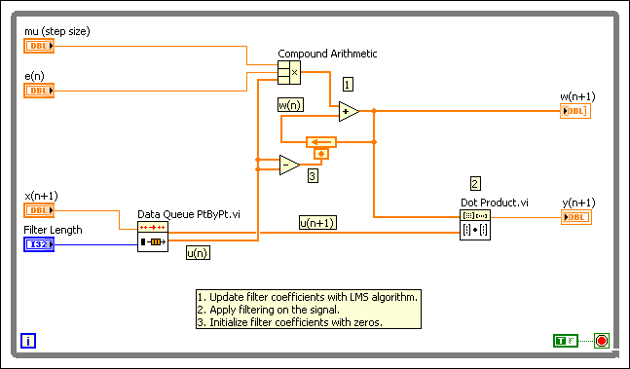The NI LabVIEW Adaptive Filter Toolkit provides tools for designing, analyzing, and simulating adaptive filters, including both floating- and fixed-point. We can use these tools to create adaptive filters with various algorithms, such as least-mean-square (LMS) and recursive-least-square (RLS), as well as their variants. We can apply the adaptive filters    we    create    to different applications,   such   as   adaptive noise cancellation, adaptive echo cancellation, system identification and Prediction, among others. You   also   can   create   and implement fixed-point    adaptive   filters   on   NI field-programmable    gate   array   (FPGA) targets.

**Summary**

1. We can use NI LabVIEW to implement a graphical model for the prediction filter, and then LabVIEW will generate the VHDL code for FPGA.[4]
2. NI LabVIEW has module for the wireless sensor networks, so we can simulate the performance of the WSN based on the new prediction filters using this module.[5]
3. The generated VHDL code is designed to program NI FPGA hardware such as CompactRIO; but we can use [The LabVIEW FPGA for Xilinx SPARTAN-3E XUP Driver](https://lumen.ni.com/nicif/us/infolvfpgaxilsprtn/content.xhtml) to program Spartan 3E FPGA Kit.[3]

**References**

1. http://www.ni.com/labview/
2. <http://digital.ni.com/public.nsf/websearch/5BACE1997875557D862577650029C748?OpenDocument>
3. <http://www.dbaasco.com/vb/t1982.html>
4. <http://zone.ni.com/reference/en-XX/help/372357A-01/lvaftconcepts/aft_prediction/>
5. <http://sine.ni.com/nips/cds/print/p/lang/en/nid/206916>